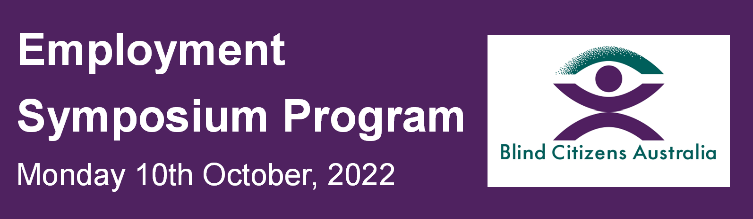
This Employment Symposium is a part of Blind Citizens Australia's 'An Eye to the Future' project.

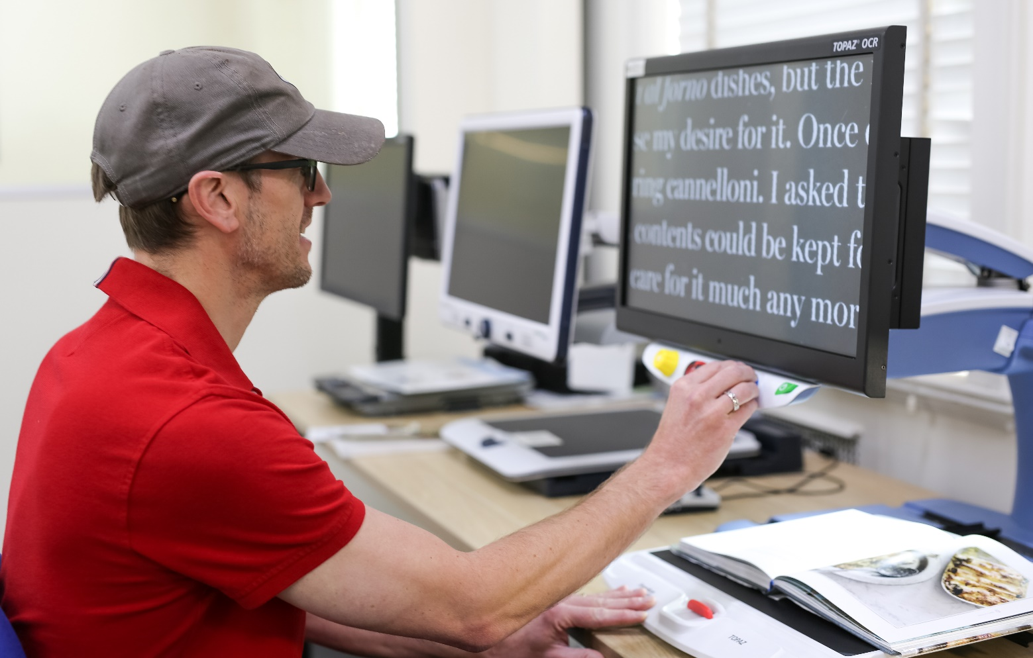
Image description: A man in a red shirt wearing a hat and dark glasses is sitting at a desk with an overhead projector on the desk. He is reading the large text on the screen in front of him, with the book open below the screen.

9:00am – 10:30am Session 1

Welcome and Housekeeping

Nicole Willing, Project Manager - An Eye to the Future Project

Blind Citizens Australia (BCA)

Nicole is a senior leader in project management and the aged and disability sectors in the not-for-profit sector, with comprehensive knowledge of blindness and lived experience of low vision.

Acknowledgement of Country

Stephen Belbin, BCA Vice President, Branch Liaison Officer and Chair Business Continuity Committee

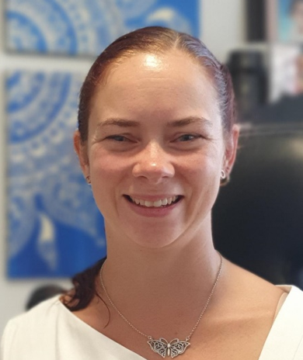
Image of Sally Aurisch facing camera and smiling

SALLY AURISCH

CEO, Blind Citizens Australia

Topic: About Blind Citizens Australia (BCA) and our work to change community perceptions of people who are blind or vision impaired
Sally Aurisch is a not-for-profit, community and disability sector leader. A vision impaired leader herself, Sally is passionate about access, inclusion, and accessible education, and employment. Sally will speak about the work of Blind Citizens Australia and about changing community perceptions of people who are blind or vision impaired in the workplace.

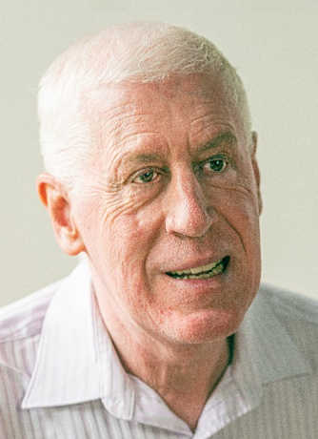
Image of Graeme Innes AM facing the camera.

GRAEME INNES AM

Keynote speaker

Topic: Barriers to employment for people who are blind or vision impaired
Graeme Innes AM is a lawyer, mediator and company director, and was Australia's Disability Discrimination Commissioner from December 2005 to July 2014. Graeme has also recently been appointed as a Director of the National Disability Insurance Agency (NDIA). Graeme will address the barriers to employment for people who are blind or vision impaired and the misconceptions or myths among employers.

10:45am – 12:30pm Session 2

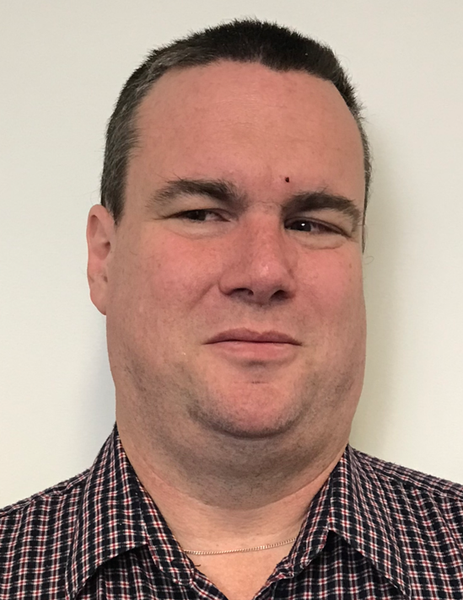
Image of Vaughn Bennison facing the camera

VAUGHN BENNISON

Executive Officer, Disability Voices Tasmania

Topic: How to make your workplace more accessible and inclusive
Vaughn Bennison will provide first-hand experience of what it is like being blind and working in an executive role. Vaughn will also discuss how assistive technology can assist blind employees in the workplace. Vaughn will also be a speaker on our ‘You Can’t Ask That’ panel presentation later in the Program.

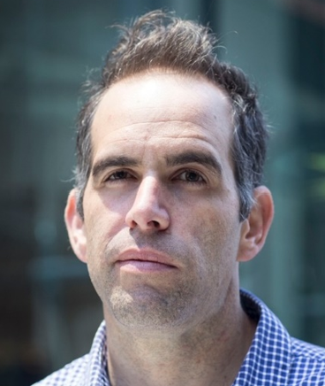
Image of Rocco Cutri wearing a blue check, facing the camera

ROCCO CUTRI

Solutions Architect - KPMG

‘You Can’t Ask That’ Panel Presentation
Rocco Cutri is a Solutions Architect at KPMG Australia. Rocco has been blind for over 8 years and will be one of the participants on the 'You Can't Ask That' Panel which is designed to break down stereotypes about people who are blind or vision impaired.

ROSLYN SACKLEY

Mentor – Canberra Blind Society

‘You Can’t Ask That’ Panel Presentation
Roslyn is a proud Ngiyampaa woman from the central west of NSW but currently resides on the Central coast. She has total vision loss through Meningitis as an infant. Ros has been an educator for most of her working life and has taught in the ACT and NSW in the primary, senior secondary, TAFE and university sectors. She has participated in various research projects predominantly with Dr Sharon Kerr now at the Centre for Disability Studies. Ros established a micro business in 2015 and specialises in Braille and audio production, and is extremely interested in numerous human rights issues including employment, education, housing, health of people with disability and wider issues concerning refugees and asylum seekers.

GUIDE DOGS NSW

Workplace Orientation and Mobility (O&M)

Topic: Understanding how an employee who is blind moves safely, efficiently, and effectively from one place to another
Guide Dogs will provide information about how dog guides behave in the workplace and how O&M training can be used to assist staff who are blind or vision impaired in the workplace, as well as getting to and from the workplace.

Quantum Technology

Assistive Technology in the workplace

Topic: Understanding the technology available for employees who are blind or vision impaired
Quantum Technology’s presentation will introduce the different types of screen reading software and special talking and braille devices that allow employees who are blind or vision impaired to use computers, mobile phones and other electronic devices independently in the workplace.

1:25pm – 3:00pm Session 3

JOBACCESS

Topic: How JobAccess can support employers
JobAccess is the national hub for workplace and employment information for people with disability, employers, and service providers. JobAccess will provide information to employers about what financial support is available to employers, as well as what other non-financial resources and services are available to help you employ people with
disability.

Bindi Maps

Topic: Navigating Unfamiliar Spaces
Bindi Maps will guide you on how to make indoor spaces accessible, as well as showing how people who are blind or vision impaired can navigate indoor spaces and get to their chosen destination.

BRYAN RUHLE

Neuron Mobility

Topic: How to support an employee who is blind or vision impaired
Neuron is the leading rental e-scooter company and micro-mobility technology developer operating in cities across Australia, New Zealand, the United Kingdom, and Canada. Bryan will speak about Neuron's experience in taking on an intern who is deafblind.

3:20pm – 4:30pm Session 4

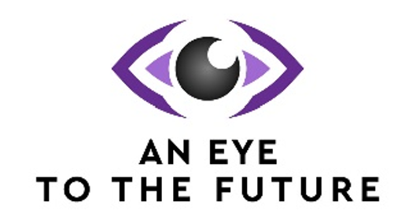

MADI BRAIM

Project Officer, An Eye to the Future project

Blind Citizens Australia (BCA)
Topic: The journey through BCA’s Internship Program
Madi Braim will talk about BCA’s Internship Program and provide information on how BCA’s ‘An Eye to the Future’ team support employers and interns through the internship process and give some examples of our success stories. Madi will also present a video from one of the businesses that participated in our Internship Program in 2022.

LINDY HOU, PETER GRANLEESE AND CLAIRE MANNING

Canberra Blind Society

Topic: Employment Empowerment – Encouraging everyone to work together to understand and maximise the abilities of people with a vision impairment to achieve positive employment opportunities and workplace outcomes for all
Lindy Hou, Peter Granleese, and Claire Manning will talk about Canberra Blind Society's Mentoring Program and the resources and activities that will improve your organisations’ understanding of how to reduce the challenges and barriers that employees who are blind or vision impaired often experience in the workplace.

LINDY HOU

Mentor – Canberra Blind Society
Lindy worked in the Information Computer Technology (ICT) industry where she transitioned from being fully sighted to legally blind over a 15-year career. In the final 11 years of this career Lindy worked as a consultant with many large corporations and government departments to implement and convert accounting systems. Lindy has extensive knowledge of various adaptive technologies which would enable people with impaired vision to be as productive as those fully sighted.

PETER GRANLEESE

Mentor – Canberra Blind Society
Peter graduated from the University of NSW, Law School with an Arts/Law degree in 1979. In 1980 Peter moved to Canberra and joined the Public Service. He worked for 7 years at the Australian Taxation Office and then moved across to ACT Government in 1988. First with the Government Solicitors and then Office of Fair Trading. For the next 20 years Peter had various management and legal roles in areas including policy, legislation, compliance and client service. Since 1981 alongside his public service career, Peter has shared his experience and support to several community service organisations in a variety of Committee and Leadership roles.

DR CLAIRE MANNING

Project Officer – Canberra Blind Society
Claire is the Canberra Blind Society Project Officer for the Mentoring Program. Claire joined Canberra Blind Society with over 20 years working successfully in a variety of learning, development, facilitation, co-ordination, consulting, and research roles collaborating with both private and public sector organisations. In the last decade, Claire has worked as a project coordinator, researcher, program designer and facilitator in the university and community sectors. Her project work has built skills and knowledge in a range of areas including advocacy, disability, inclusion, education, allied health, Indigenous health and supporting older Australians. Claire has a Masters of Adult Education with a PhD and she is a passionate advocate for education, inclusion and the arts and uses her extensive knowledge and skills to work with and support when needed individuals of all abilities.

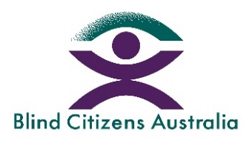

Closing Summary

Deb Deshayes, General Manager – Projects and Engagement

Blind Citizens Australia (BCA)
Deb has extensive leadership experience in the disability and not-for-profit sectors and has experience as a previous business owner. Deb has been a provider of workplace coaching. senior advisor in customer experience and engagement, and she has extensive knowledge of blindness and low vision, both professionally and personally.

